

**Problem 1:**

**Two versions of deployment of helm charts**



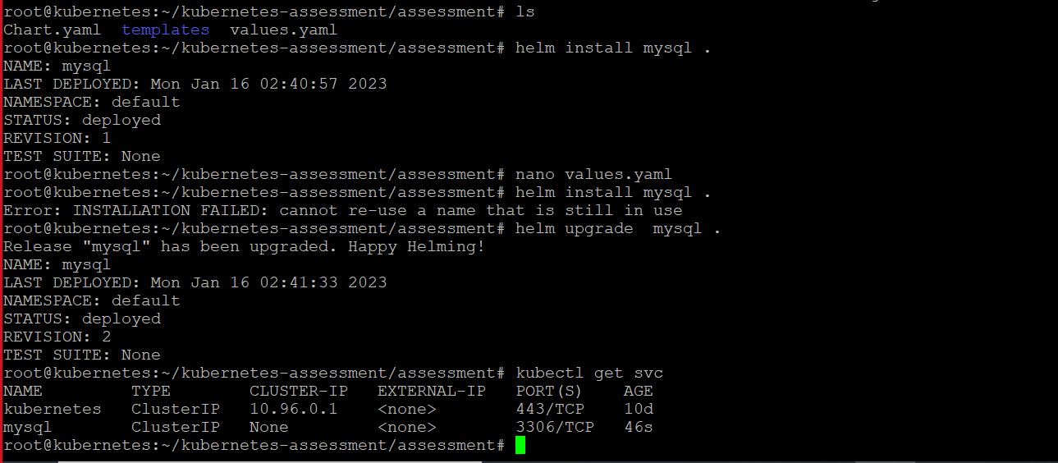

**Problem 2:**



**Values.yaml**

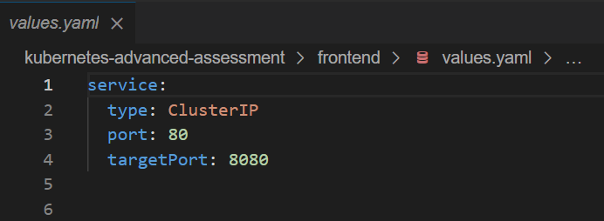

**Fronted deployment created**

**Values.yaml updated**

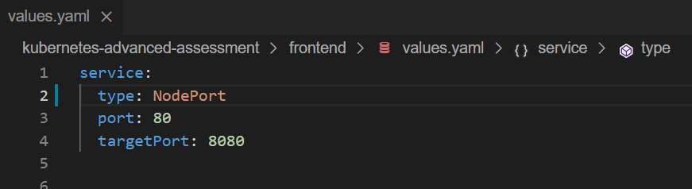

**Values.yaml**

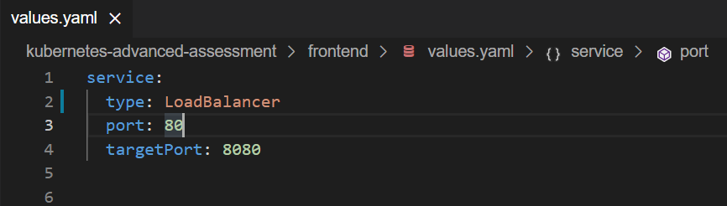

**Deployment updated**

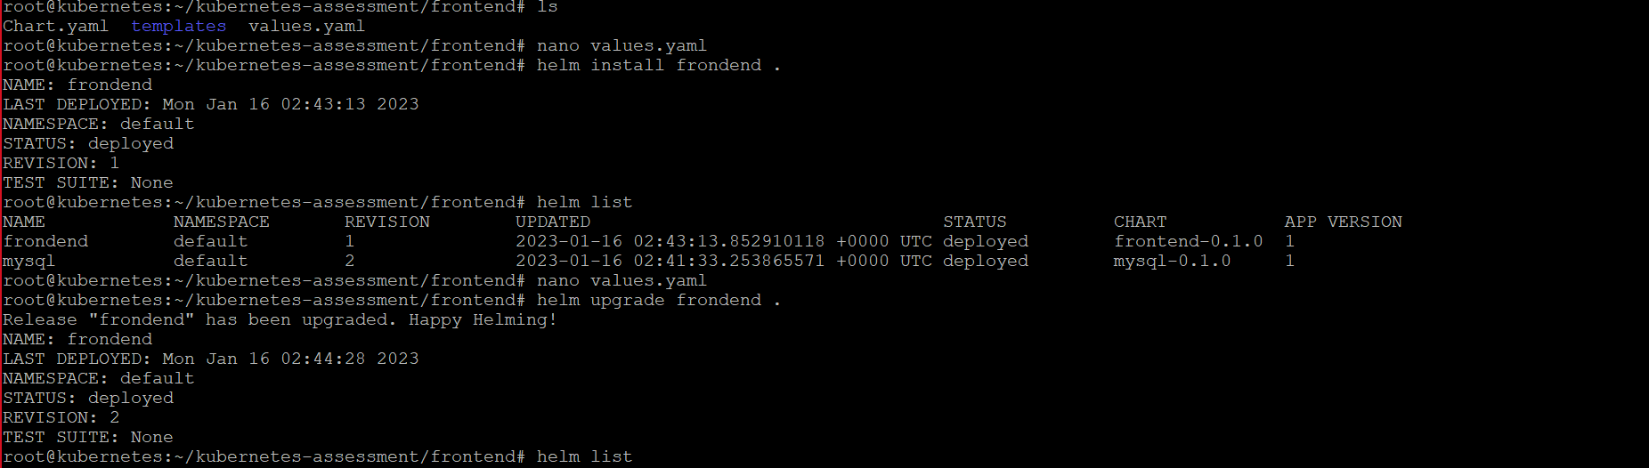

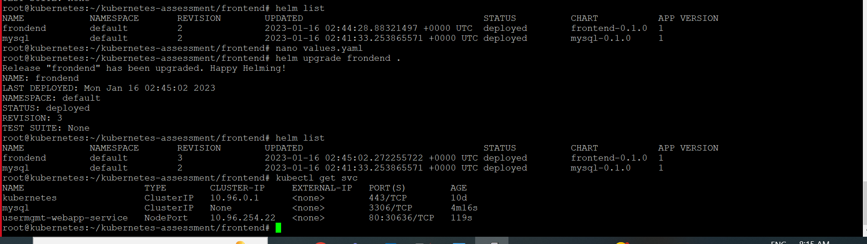

**ON WEB:**

